The thief on the cross
Reading: Luke 23:32-33, 39-43
Two other men were also led out with Jesus to be killed. Both of them had broken the law. The soldiers brought them to the place called The Skull. There they nailed Jesus to the cross. He hung between two criminals. One was on his right and one was on his left.
One of the criminals hanging there made fun of Jesus. He said, “Aren’t you the Messiah? Save yourself! Save us!”
But the other criminal scolded him. “Don’t you have any respect for God?” he said. “Remember, you are under the same sentence of death. We are being punished fairly. We are getting just what our actions call for. But this man hasn’t done anything wrong.”
Then he said, “Jesus, remember me when you come into your kingdom.”
Jesus answered him. “What I am about to tell you is true. Today you will be with me in paradise.”

Thought about the reading
It will soon be Easter. This is the time when we like to eat chocolate Easter eggs! It is also the time when we remember how Jesus died. People who did not like Jesus arrested him and gave him to the Roman authorities. They asked the Romans to kill him on a cross.
On Good Friday, we remember how Jesus died on the cross. He was killed with two other men, who were thieves. One of them made fun of Jesus even when they were all dying. But the other thief recognised that Jesus was someone special who had never done anything wrong. The thieves deserved to die, but Jesus did not. He asked Jesus to remember him. Jesus replied that he would be with him in paradise! Jesus forgave him for the things he had done wrong and promised him life in paradise after he had died!
When he died on the cross, Jesus took the punishment we deserve. So, it doesn’t matter what we have done, Jesus will forgive us if we tell him that we are sorry. He will give us life with him in paradise (heaven).

Prayer
Dear Jesus, thank you that you died for me on the cross. Thank you that you took the punishment for the things I do wrong. I am sorry for all the wrong things I have said and done. Please forgive me.
Thank you that I know you will forgive me and give me life in heaven with you for ever.
Amen

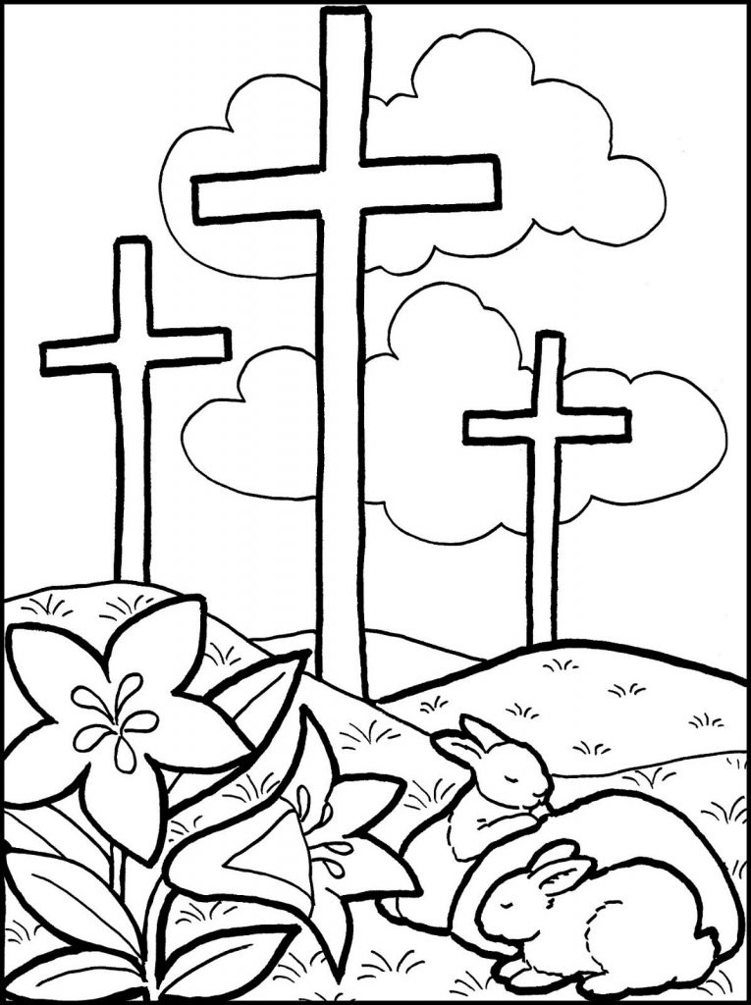
Happy Easter

Cambridge Causeway

Spring 2025
Bible Study notes

People changed by Jesus
7. The Thief on the Cross
By Chrissy Cole

The next Causeway meeting is on April 23rd at 7.30pm in St Martin’s Church Hall.

